Name :- Pralay K Kalaskar

Mail :- ([pkkdkalaskar71@gmail.com](mailto:pkkdkalaskar71@gmail.com))

Phone :- +91-7066216365

Linkedin :- [www.linkedin.com/in/pralay-kalaskar-1010](http://www.linkedin.com/in/pralay-kalaskar-1010)

SQL Assignment_Part3 - SET 3

Starts Here :- P.T.O.



SET 3

-----

1. Write a stored procedure that accepts the month and year as inputs and prints the ordernumber, orderdate and status of the orders placed in that month.

***Example***: call order_status(2005, 11);

**Answer :-**

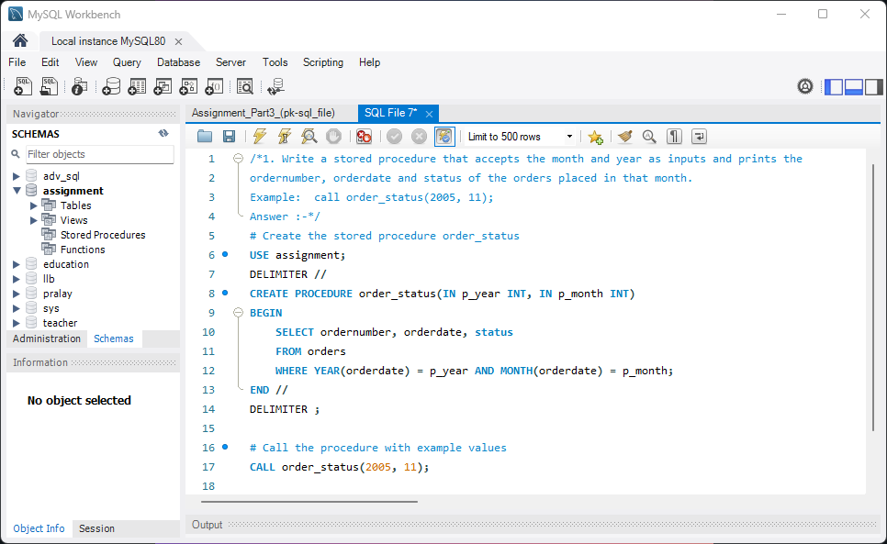

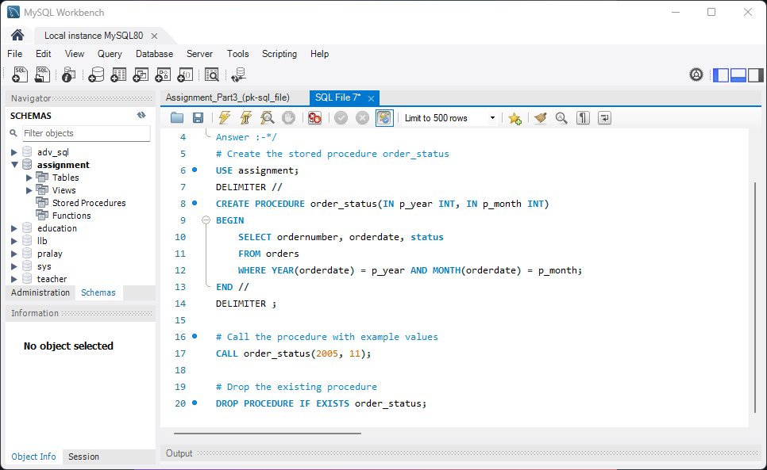

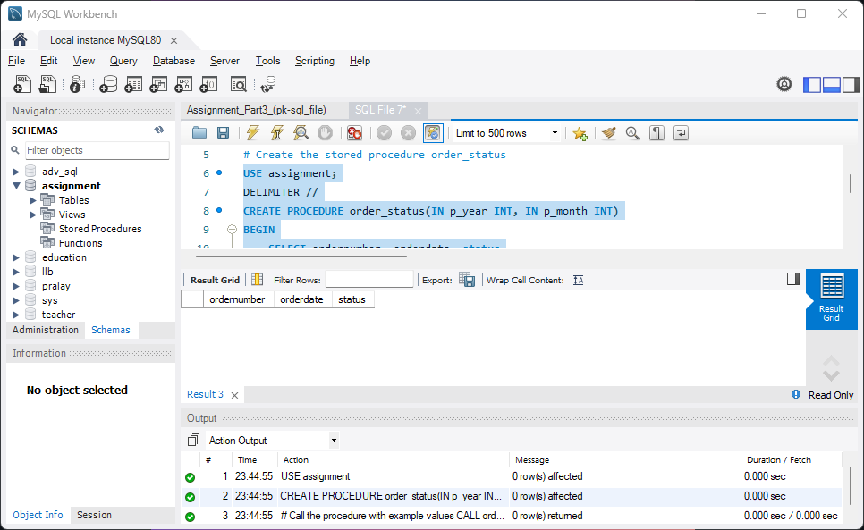

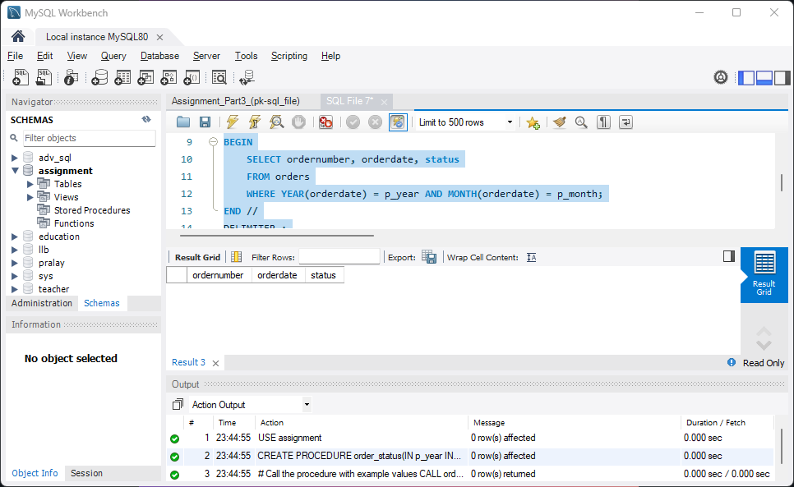

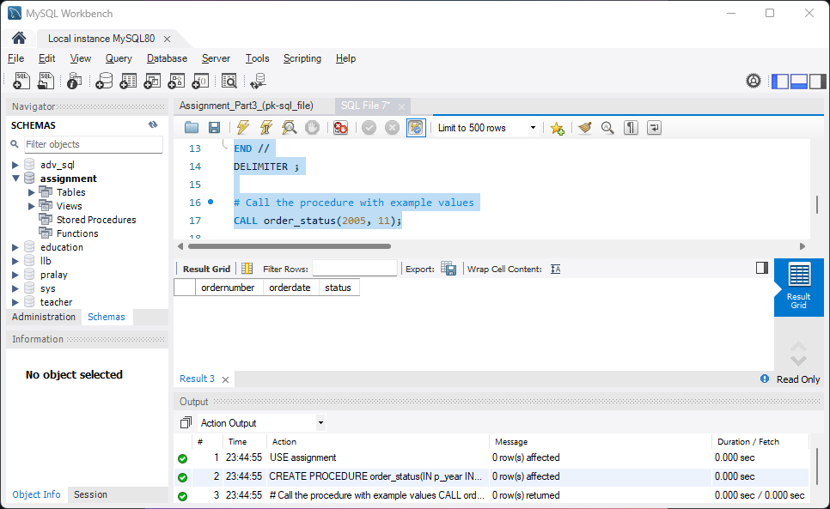

2. a. Write function that takes the customernumber as input and returns the purchase_status based on the following criteria . [table:Payments]

if the total purchase amount for the customer is < 25000 status = Silver, amount between 25000 and 50000, status = Gold

if amount > 50000 Platinum

b. Write a query that displays customerNumber, customername and purchase_status from customers table.

**Answer :-**

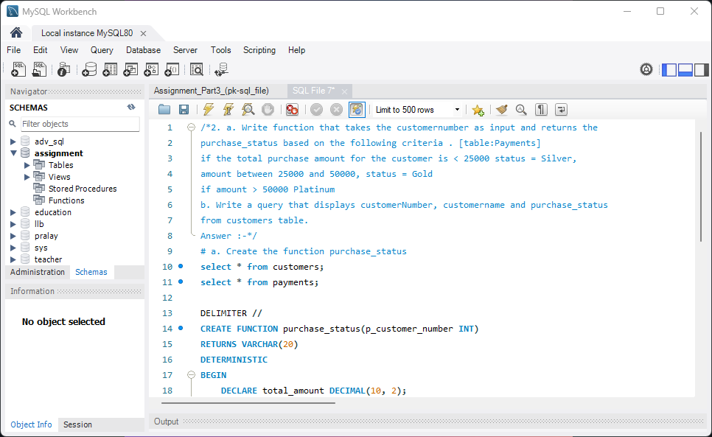

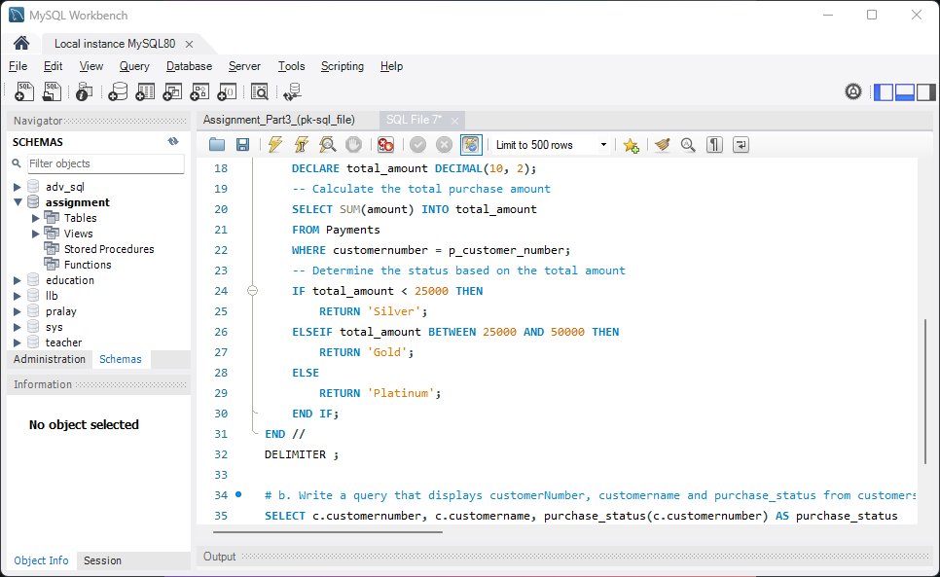

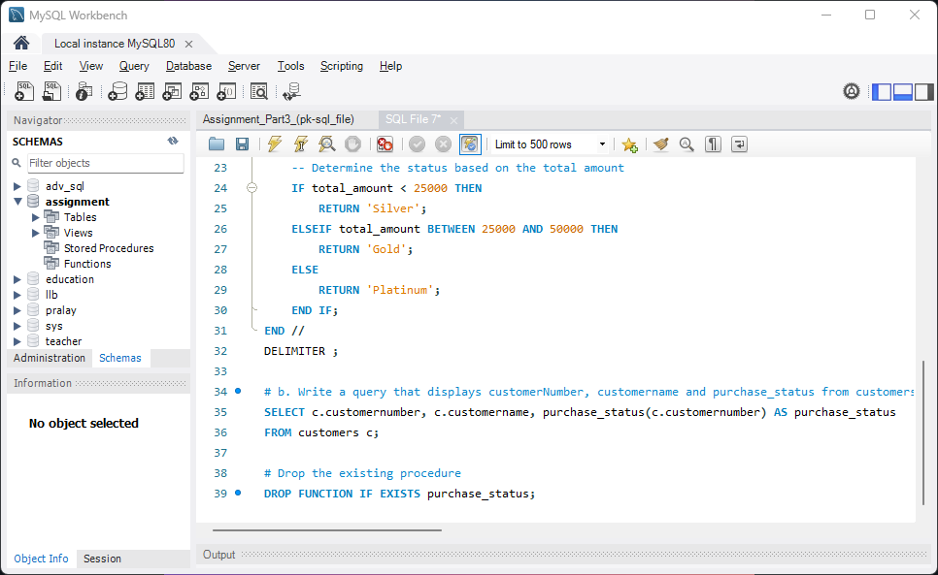

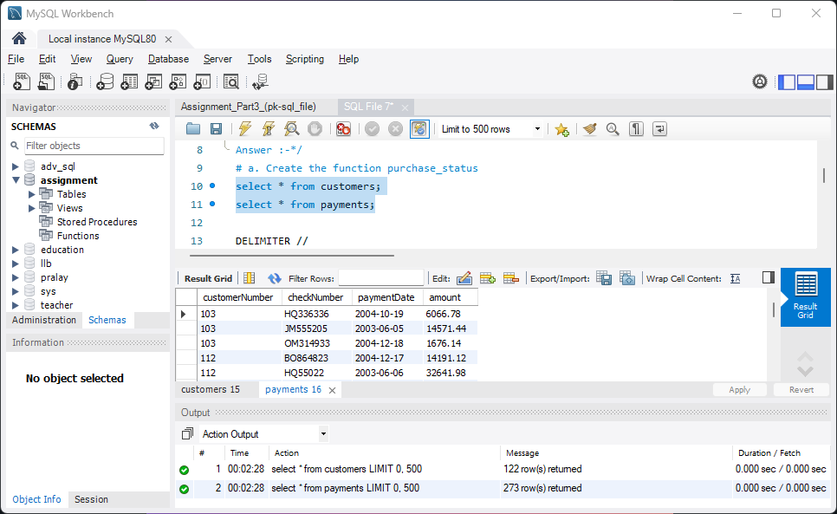

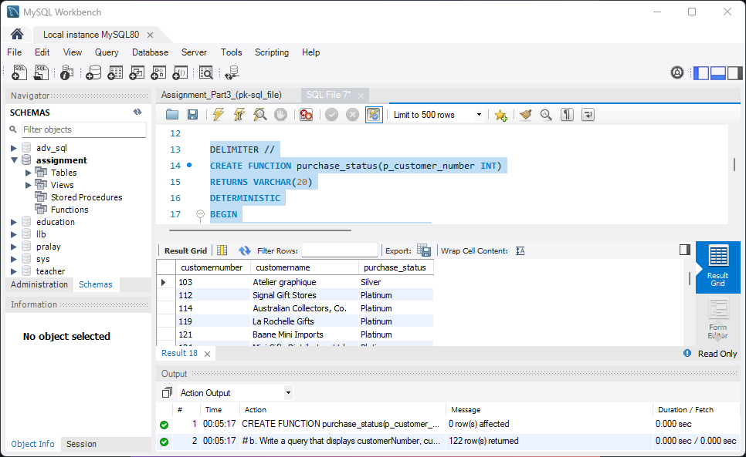

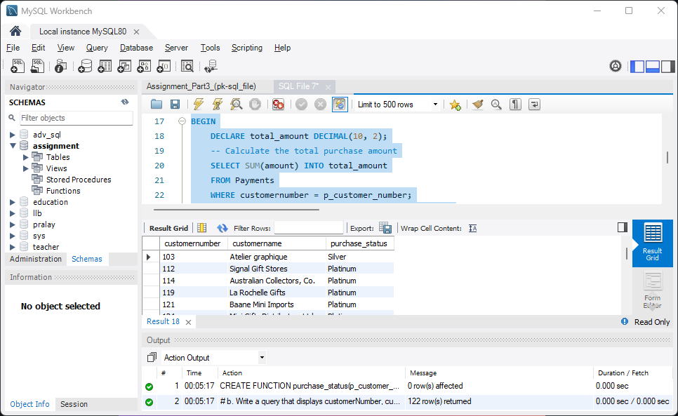

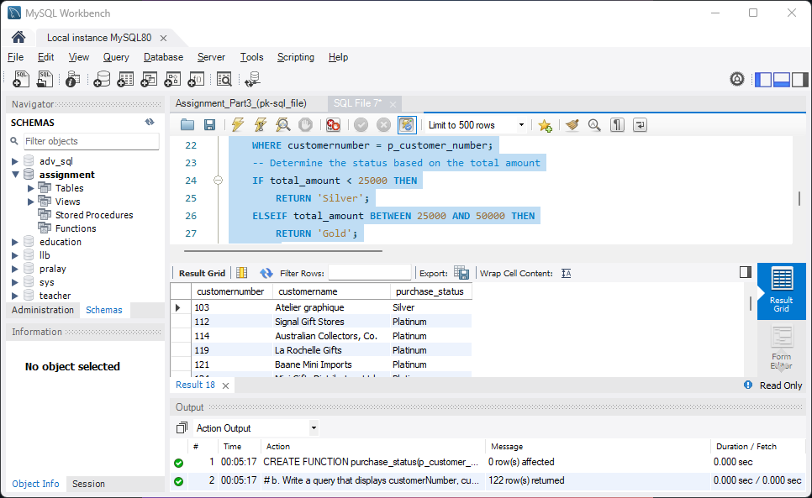

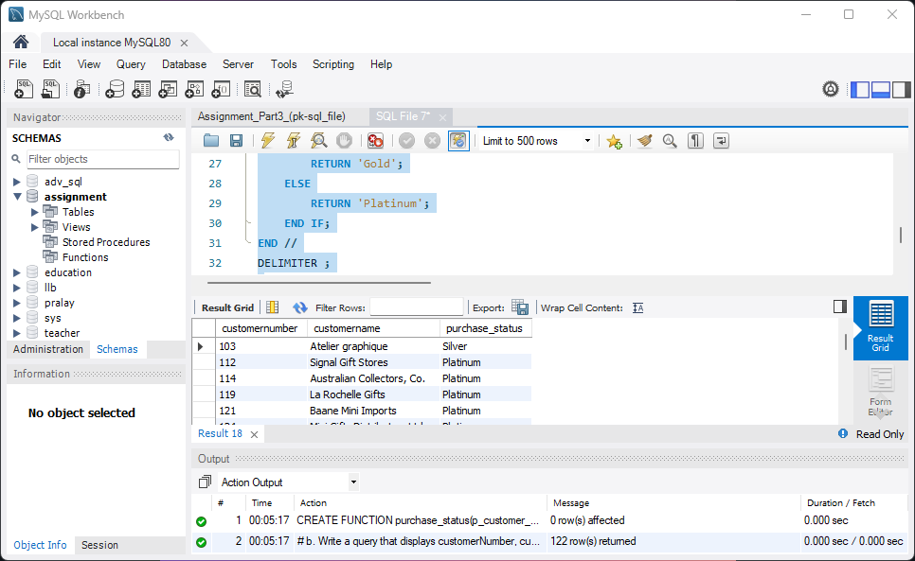

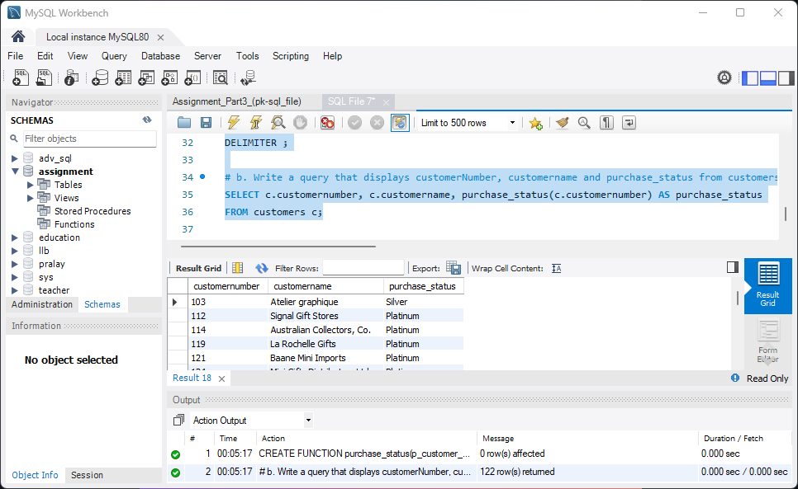

3. Replicate the functionality of 'on delete cascade' and 'on update cascade' using triggers on movies and rentals tables. Note: Both tables - movies and rentals - don't have primary or foreign keys. Use only triggers to implement the above.

**Answer :-**

4. Select the first name of the employee who gets the third highest salary. [table: employee]

**Answer :-**

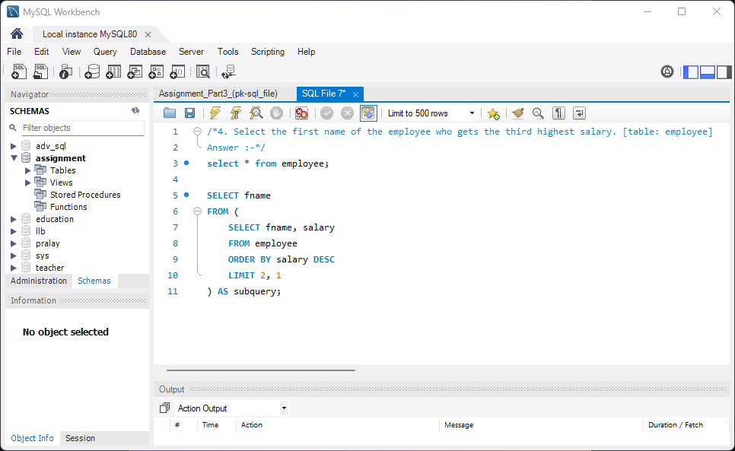

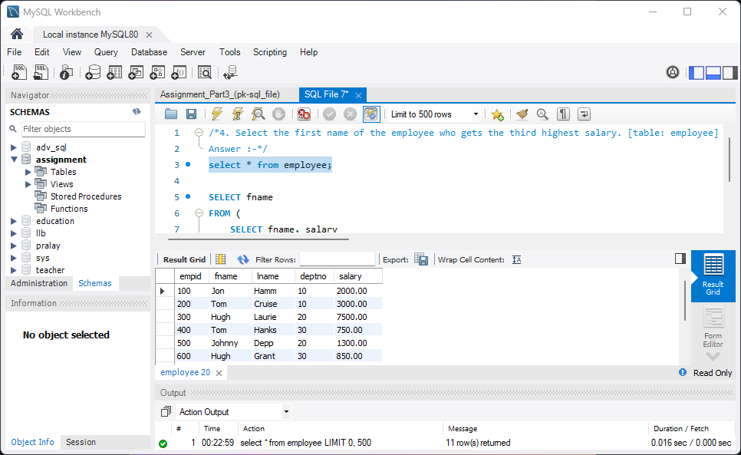

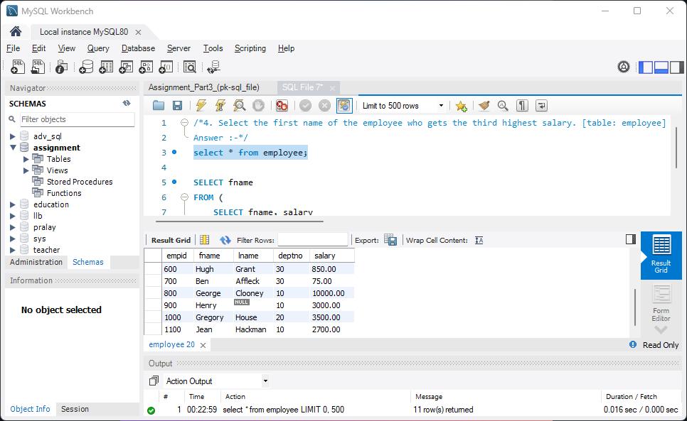

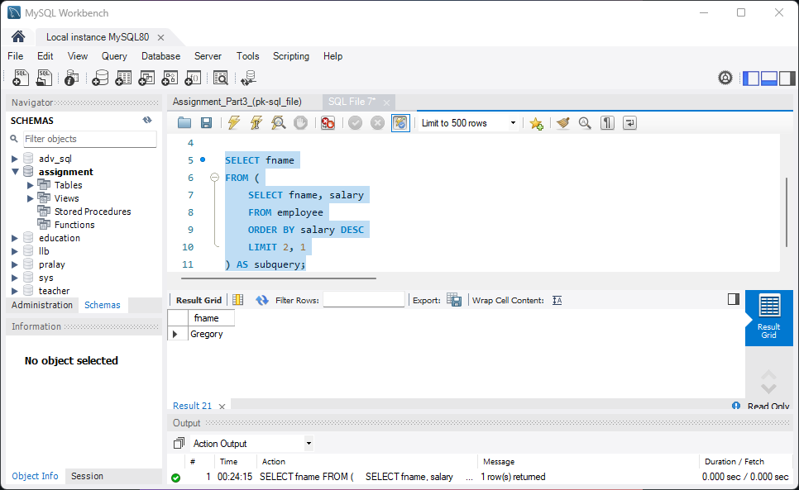

5. Assign a rank to each employee based on their salary. The person having the highest salary has rank 1. [table: employee]

**Answer :-**

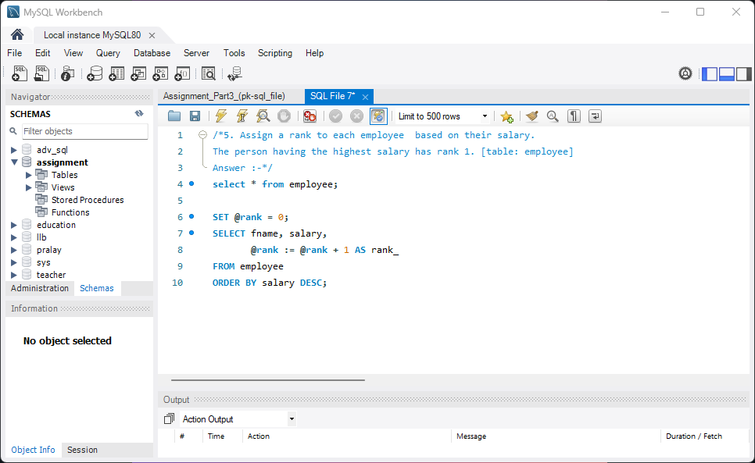

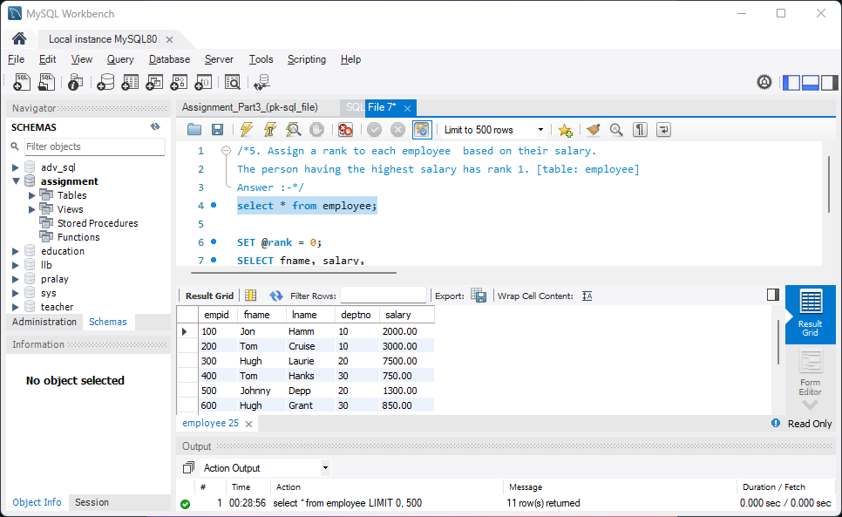

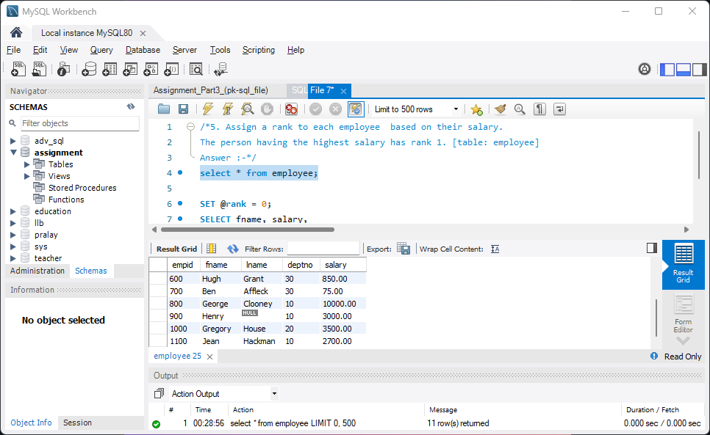

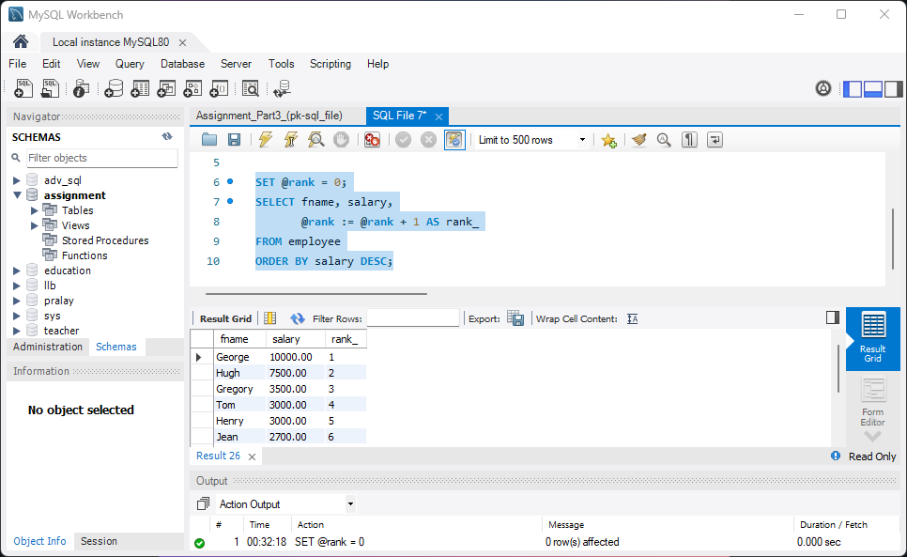

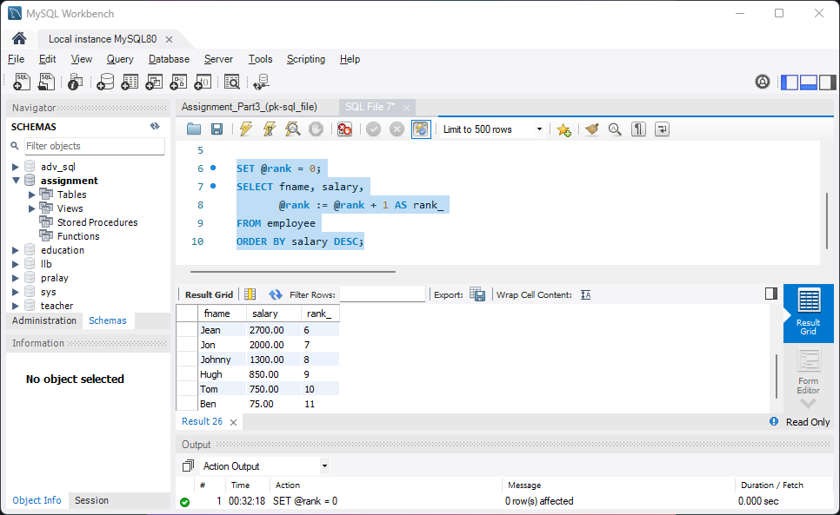

END.